Task: Disassemble PC and take a photo of every component also mention what is the use of each component

CPU:

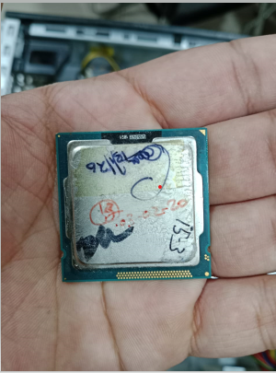

CPU is known as the brain of the computer. It processes informations and it’s arithmetic logic unit performs calculations.

Motherboard:
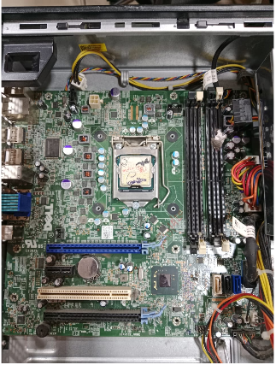
Motherboard is main circuit of system. Motherboard is basically connects all hardware components like connections of RAM, CPU, GPU and SMPS. It works like network of roads.
SMPS:

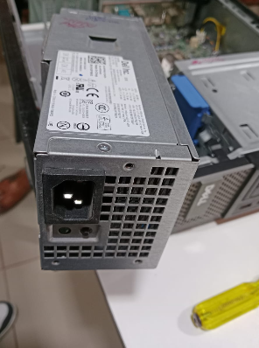

Full form of SMPS is switch mode power supply. SMPS basically provides electricity or power to other hardware components. It connects with HDD/SSD and Motherboard with wire for power connectivity.
HDD:
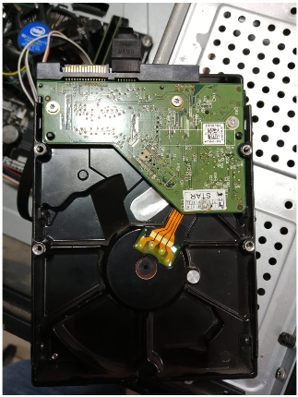

HDD is provide space for store some things of PC. Basically it stores everything of PC like files, software and more. HDD have moving parts and it works slower than SSD.

RAM:

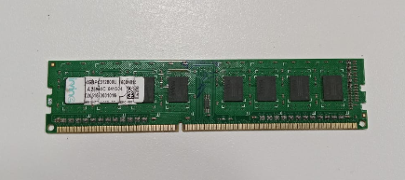

RAM is basically works like study desk, When we are running some things on our PC that time RAM gives space for perform our work on PC. If RAM is big, we can perform multiple tasks perfectly at same time.

